Pressure wave propagation
Due to the Joule heating by the proton beam, the temperature of the LBE rises locally during the pulse. The heating induces a thermal expansion. The thermal expansion pushes the surrounding fluid radially outward, so that a pressure peak forms along the proton beam axis. At the end of the pulse, the fluid is still propagating outwards while the thermal expansion has come to an end, resulting in tensile stresses along the proton beam axis. If the tensile stress exceeds the tensile strength of the liquid, it is torn apart and void is formed. The formation of void is often referred to as cavitation or liquid (water) hammer. This effect is most pronounced where the heat deposit has its maximum value. Three instances of pressure wave formations are observed, i.e. at the beginning of the pulse, the end of the pulse and the collapse of the void.
The proposed target modules differ substantially with respect to their response to pressure waves. In the window target module, the channel is fully filled with LBE. The pressure wave hits the enclosing structures, leading to their deformation. The stiffness is here an essential property. For soft walls or thin membrane type walls (window) the structure deforms according to the pressure like the open end of a vibrating pillar where vanishing normal stresses are observed. On the other hand, for a stiff wall inertia is so high that it cannot follow the excitation, potentially exceeding the tensile stress of the liquid at the wall. This is most critical as it results in severe cavitation damage. In this process of cavitation the relevant tensile stress is a function of the chosen liquid and the cavitation nuclei. The characterisation of the LBE with respect to tensile stress for the considered pulse duration has not been considered yet and requires experimental determination.
The propagation of the pressure wave in the target has been simulated with an SPH model. The target geometry is approximated as a 180cm long channel with a bend at 60cm. The channel section is 20cm wide and 8cm high. At the exits of the pipe, free surface conditions are considered to approximate absorbing boundaries. Since there is no knowledge of the actual rigidity of the pipe walls, the two extreme conditions of perfectly rigid walls and free surface at the sides are considered. The portion of the channel where the window may be located is always approximated as a free surface since the rigidity of the window would be very low compared to the fluid and the rest of the channel.
Since we are interested in the fast transients due to the sudden beam power deposition on the liquid metal target, we totally neglect the slow motion due to the fluid flow and of its free surface in time scales of the order of seconds. The length of our simulations will be of the order of milliseconds, with the most important phenomena taking place in the first microseconds of the simulation.
The fluid will be initially at rest.
The Equation Of State can then be expressed as:
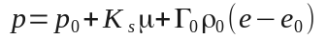
It is assumed a reference temperature of 573K, for which the density value is 10338kg/m3, the sound velocity is 1740m/s, the volumetric expansion coefficient is 127.4E-6 K⁻¹ and the specific heat c_{p} is 146J/kg K, the parameters K_{s} and Γ₀ are 31.3GPa and 2.66.
The maximum value of the negative pressure a liquid can sustain without cavitation is very difficult to measure and depends strongly not only on the temperature but also on the purity level of the material, on the presence of gas dispersed and on the time history of the load.
The literature reports lots of value for cavitation pressure for mercury, with a huge variations in the datum, of several orders of magnitude. No data was found for LBE.
In the following we assume that the limit is 150kPa a value that we used as reference in previous simulations for mercury.

Rigid walls
The pressure propagation in the fluid with the channel walls assumed to be perfectly rigid is shown in the following pictures.
A pressure wave travelling along the channel is observed, the maximum pressure value reaches 17 bar.
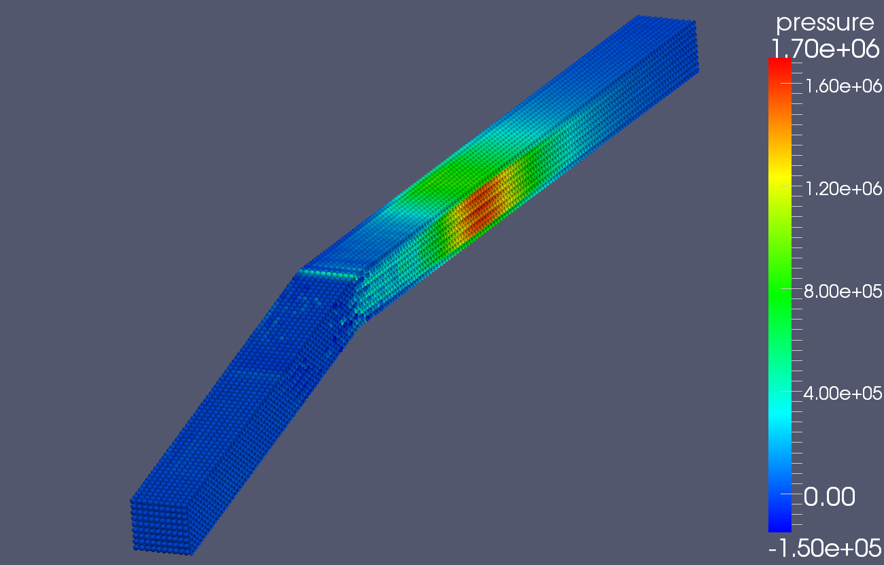Illustration 1: pressure in one half of the model at 0.8ms [Pa]

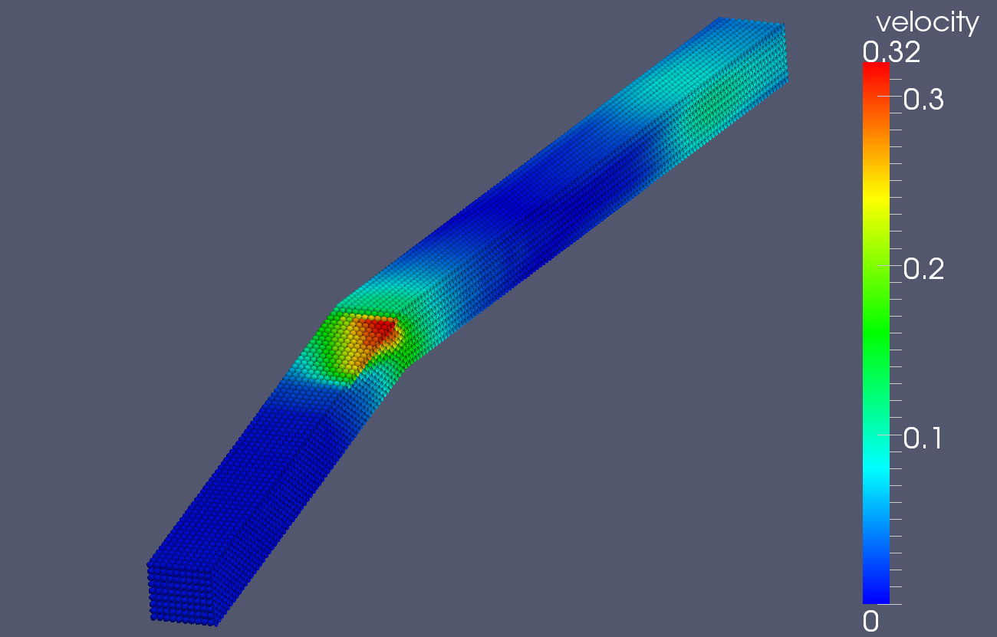Illustration 2: velocity magnitude in one half of the model at 0.8ms [Pa]

The following plot shows the pressure value at several points along the axis of the channel and along the beam direction. The origin is at the beam impact point.

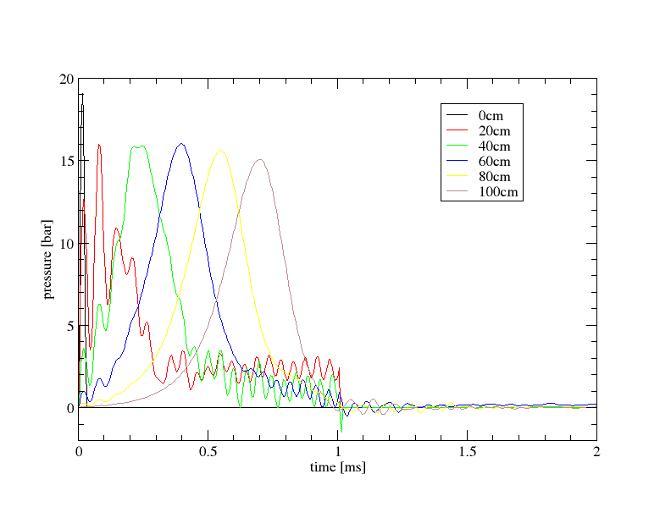Illustration 3: pressure along beam axis for rigid walls

As can be verified the pressure wave travels through the pipe without loosing much intensity. The pulse duration is 1ms, whenthe energy deposition stops a negative pressure is generated and a continuity loss occurs in the target, the pressure drops to very low values.

Free surface
In the case the channel walls are considered flexible and approximated with a free surface, the pressure wave does not travel through the pipe as can verified in the following plot. This is due to the los of continuity in the bulk material due to the different boundary conditions. The maximum value of velocity and pressure are the same.

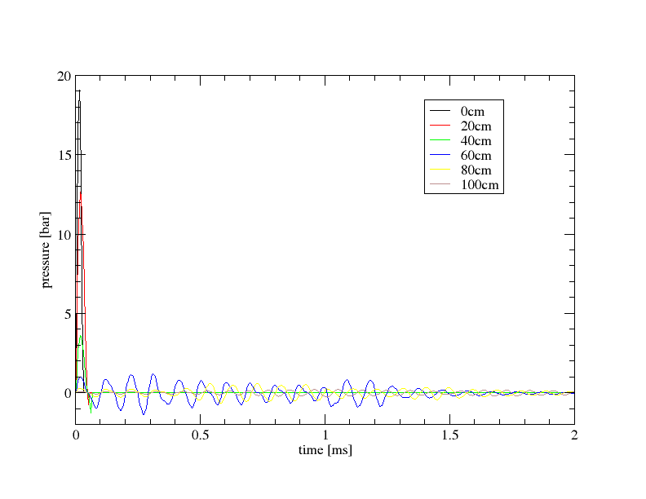Illustration 4: pressure along the beam axis for free walls

